TEAM ID: PNT2022TMID08163

PROJECT NAME: DemandEst - AI powered Food DemandForecaster

# Team Leader

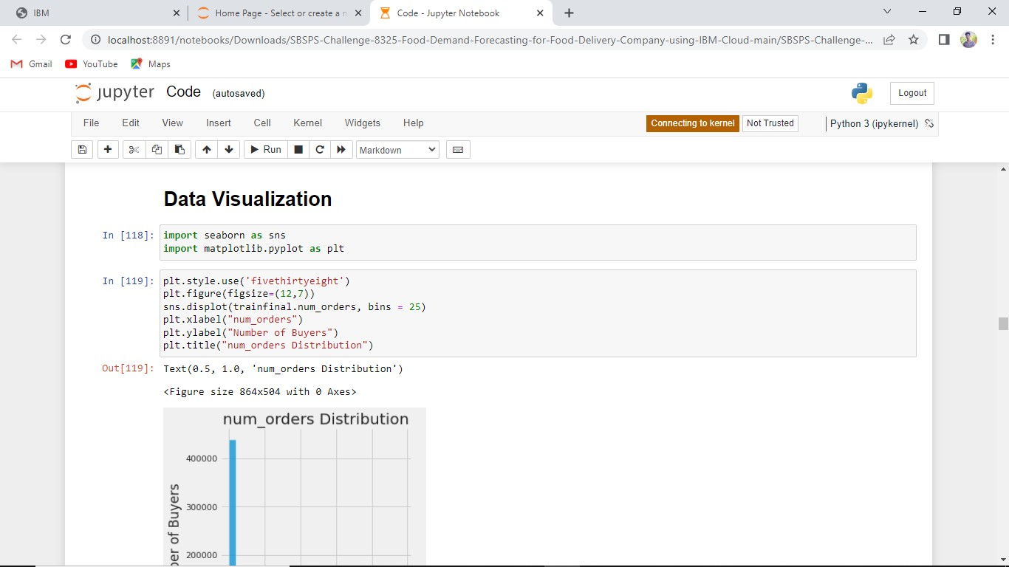

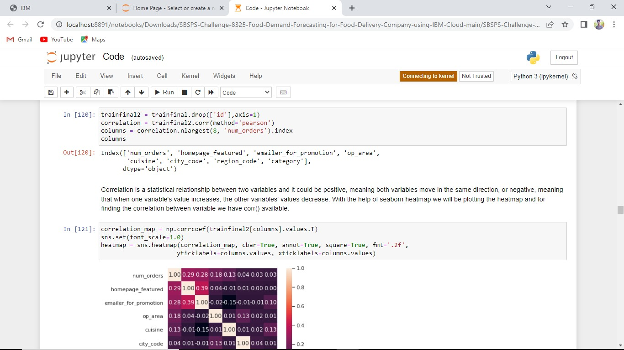

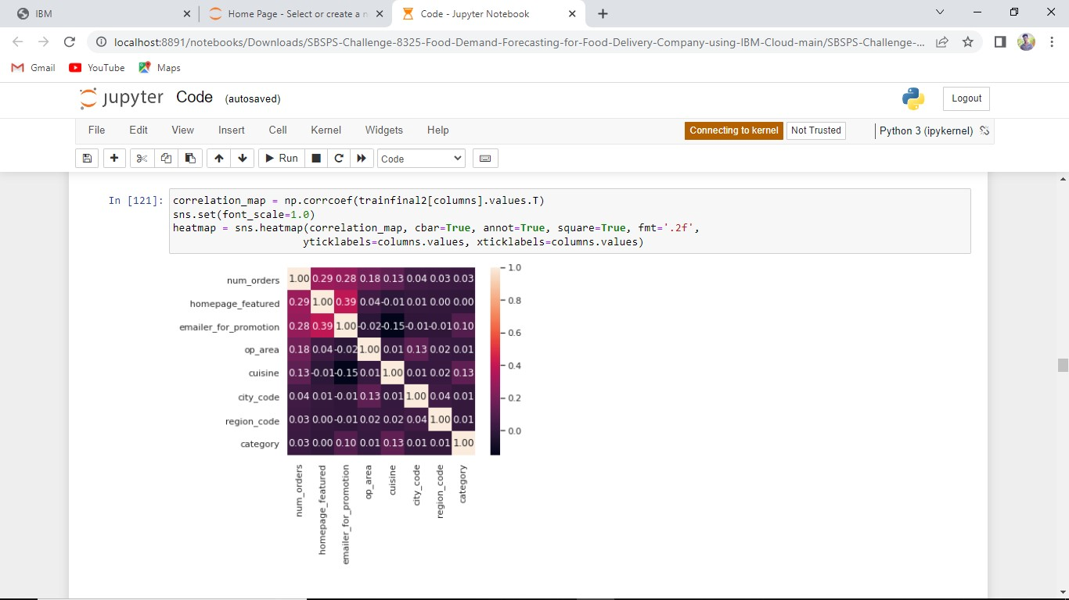

# Team Member 1



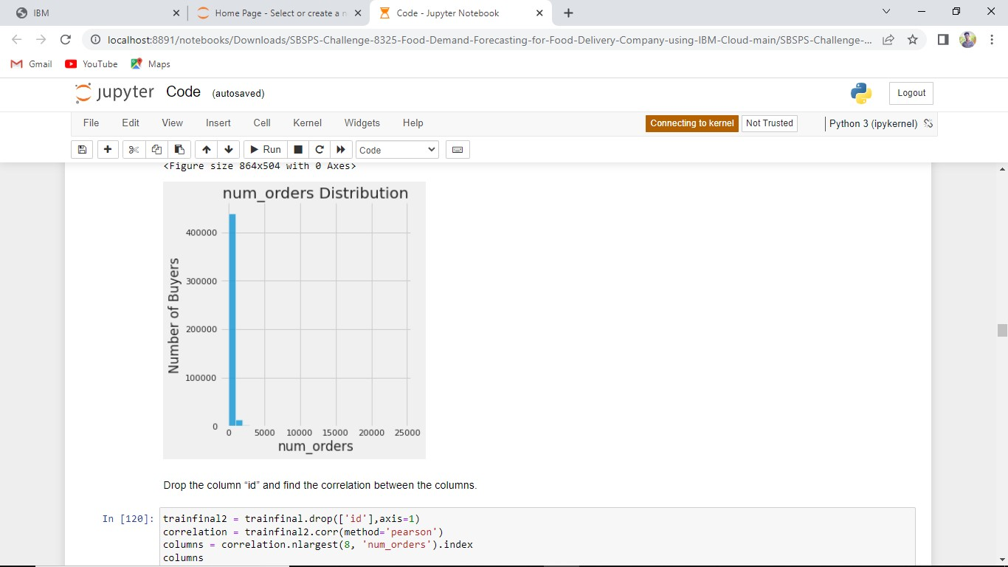





# Team Member 2









# Team Member 3







